**Assignment 17.1**

Created a text file Test.txt under /home/acadgild/

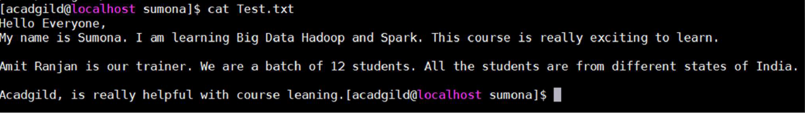

1. Write a program to read a text file and print the number of rows of data in the

document.

The command used to read the text file is:

var baseRDD = sc.textFile("/home/acadgild/Test.txt")

baseRDD is a variable into which we read the text file from the file location.



Command used to count the number of Lines in the text file is

baseRDD.count()

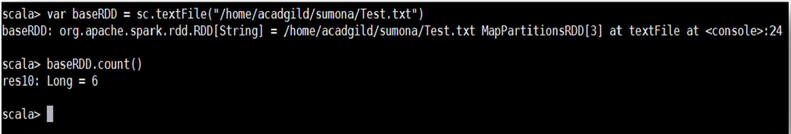

2. Write a program to read a text file and print the number of words in the document.

The command used to read the text file is:

var baseRDD = sc.textFile("/home/acadgild/Test.txt")

Command used count the number of words in the text file:

First, since the words in the text file are separated with a space(“ “), hence we will split

the text file using the flatMap split command

val wrd = baseRDD.flatMap(x => x.split(" "))

• And then now, we shall get the count of words in the text file using the following

command:

wrd.count()

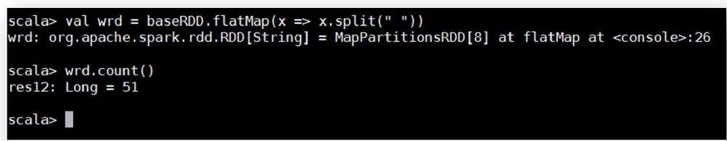

3. We have a document where the word separator is -, instead of space. Write a spark

code, to obtain the count of the total number of words present in the document.

Sample document :

This-is-my-first-assignment.

It-will-count-the-number-of-lines-in-this-document.

The-total-number-of-lines-is-3

Created the Sample.txt file

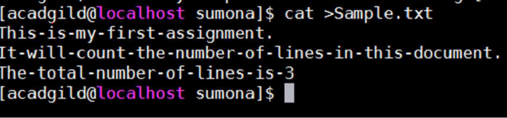

a. First we will read the Sample.txt file from the local file system to an RDD using the

command

var textRDD = sc.textFile("/home/acadgild/Sample.txt")

b. Now, since the words in the Sample.txt file are separated by a dash(-), we will first

split the text file using the command:

val countRDD = textRDD.flatMap(x => x.split("-"))

c. Now we shall count the number of words using the command;

countRDD.count()

